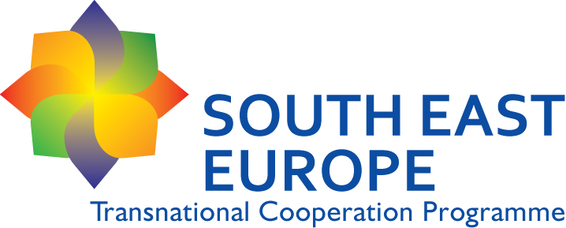
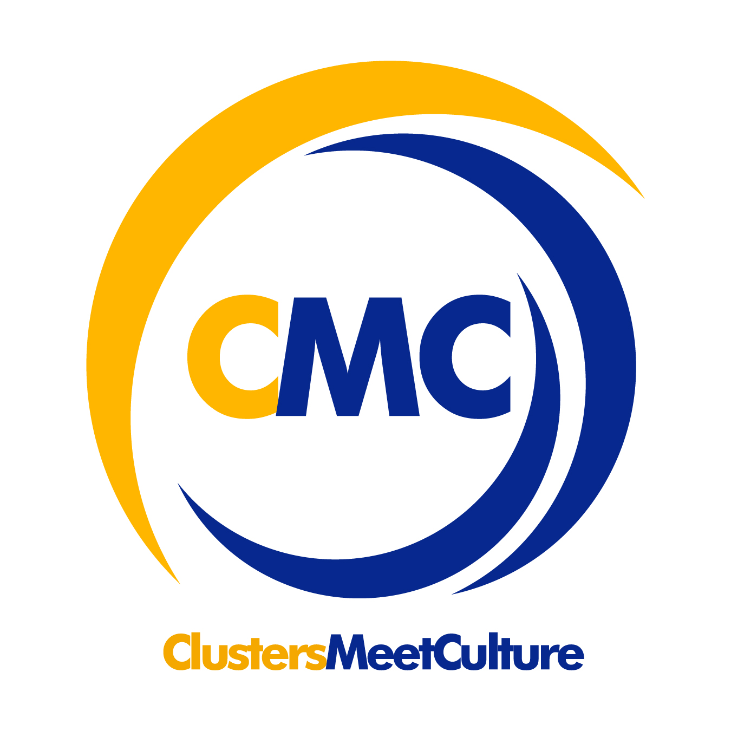

CMC – Clusters Meet Culture: an opportunity for development
REF. N° SEE/D/0302/4.3/X
THIRD PARTNERSHIP MEETING
3-4 October 2013
Maribor Development Agency, Pobreška cesta 20, Maribor

Thursday the 3rd , October 2013 – TECHNICAL PARTNERSHIP MEETING
9:30 | Welcome coffee
10:00 | Welcome speech: hosting partner RDA Maribor – Mr. Božidar Pučnik, Managing director  Brief introduction about the CMC Project state of art and agenda of the day – Veneto Region (Mrs. Cecile Anne Rousset/Ms. Valentina Colleselli)
10:30 | Presentation of the WP3 outcomes and results: presentation of the WP3 content  Mr. Szabolcs Rabb -CCIPB  Mr. János Keresnyei – CICC
11:15 | Presentation of WP4 Handbook – RDA Maribor – Mr. Vladimir Rudl
 | Brief discussion on the achieved results, document content, translation and printing of English and local level.
12:30 | Lunch break
14:00 | The CMC Project Proposed Action Plan October 2013/September 2014:  - Promotional actions  - ICT tools development  - Training actions  Veneto Region (Mrs. Cecile Anne Rousset/Ms. Valentina Colleselli)
15:00 | Promotional actions: the CMC Project Communication approach – state of the art of the main communication tools –– Province of Rimini – Mr. Enzo Finocchiario
15:45 | Coffee break
16:00 | ICT tools development: presentation of the ICT platform structure (Incipit – PR external expert)  Brief debate on the ICT Platform management and sustainability: who does what? What happen after the end of the project?
16:45 | Training actions: planning of training activities and coordination among WP 5 and WP 6 training actions:  - The transnational training to trainers event in Venice  - Local training modules implementation  - Local training workshops and involvement of tourism operators  Chamber of Industry of Slovakia – Mr. Joseph Rajtar/Chamber of Commerce of Sibiu – Mr. Alexandru Jordanescu
17:30 | Closure of the meeting
18:30 | Site visit
19:30 | Dinner

Friday the 4th, October 2013 – TECHNICAL PARTNERSHIP MEETING
8:30 | Welcome coffee
9:00 | Business models implementation: lessons learned from the implemented studies and main connection with WP 7 activities  Mr. Manfredi Vale – External Expert UCV (or Ludovica Munari/Daniela Nardello)

 | International public conference
10:00 | Presentation of the PPP Handbook materials
10:20 | Presentation of WP5 – shopping trainer services
10:40 | Questions and answers / debate, ideas, ...
11:00 | Presentation of Slovenian PPC cases (Art & Craft Centre Verzej, Art&Craft Slovenia, www.rokodelci.si)
11:45 | Presentation of Italian PPC cases (1-2 new cases)
12:30 | Networking lunch

 | CMC PROJECT - STEERING COMMITTEE
13:30 | WP1- Financial and Management issues – LP– Veneto Region (Mrs. Cecile Anne Rousset/Ms. Valentina Colleselli)
14:00 | Results of the capitalisation event held in Split on September the 17th – Cultural Sources Thematic Pole LP– Veneto Region (Mrs. Cecile Anne Rousset/Ms. Valentina Colleselli)
14:30 | Steering Committee approval:  - Handbook  - Proposed transnational training dates and locations  - ICT Platform tasks structure: who does what? Document created during the technical meeting.
15:00 | Closure of the meeting

